IMT user guide

File Sender application

- Basic application view

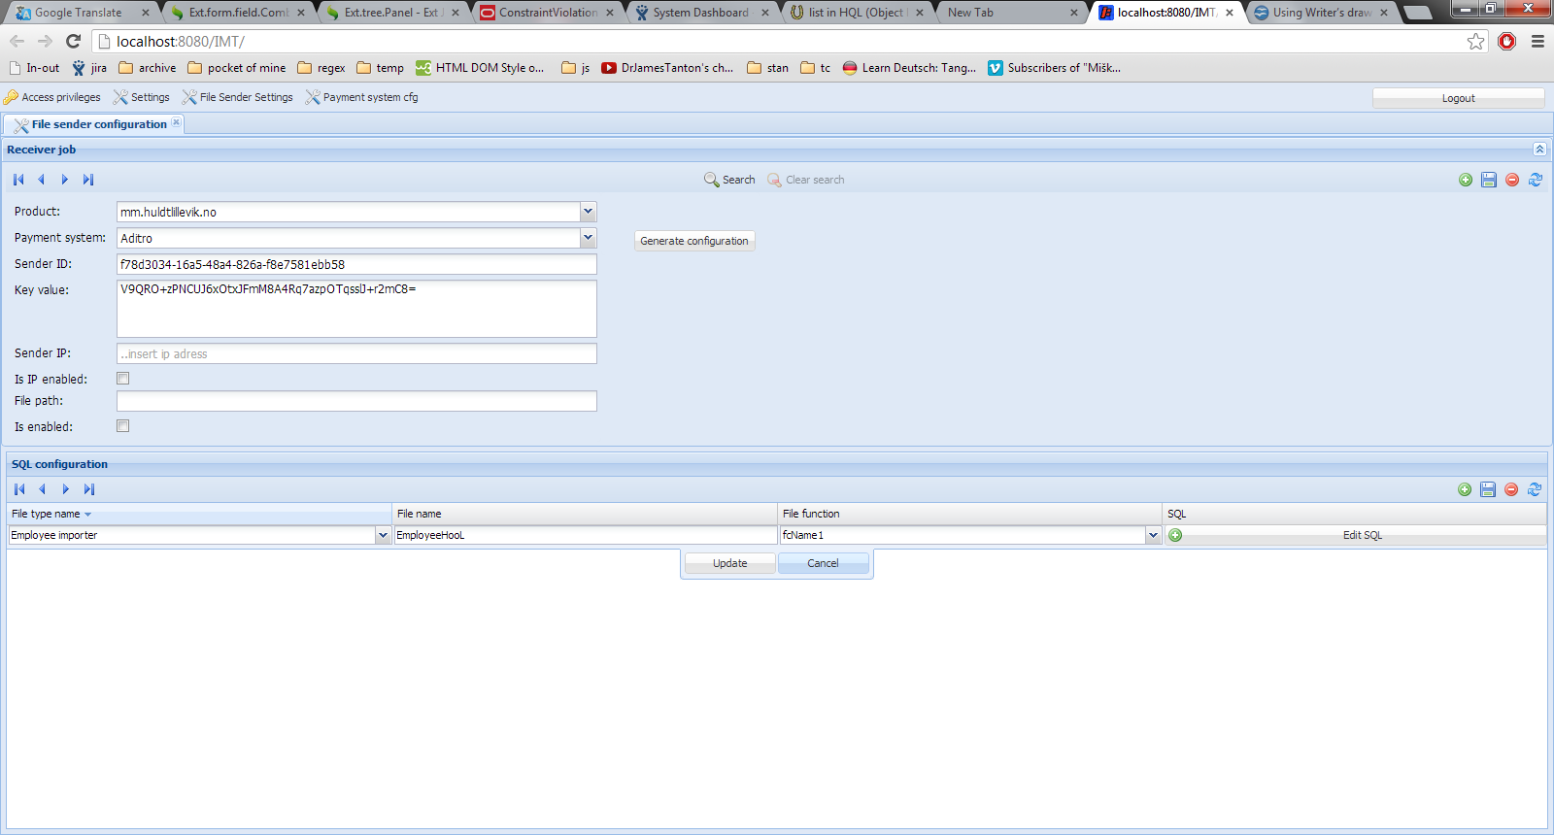

- Entities and fields

Receiver job

Fields | Description
Product | Choose Master Product
Payment system | Choose Payment system (Aditro, ..)
Sender ID(auto generate field) | Id of sender system
Key value(auto generate field) | Network encryption key
Sender IP | Ip of sender system
Is IP enabled | Enable/disable file sending from 'Sender IP'
File path | Files will be saved on 'file path' disc location
Is enabled | Enable/disable file sending

Sql configuration

Fields | Description
File type name | Choose type of file (OrgUnit, Employee, NextOfKin...)
File name | Name of file
File function | Forward 'file function' to receiver
Sql | Query that get executed to sender system

- Action bar
Use action bar buttons to control form and loaded entity.

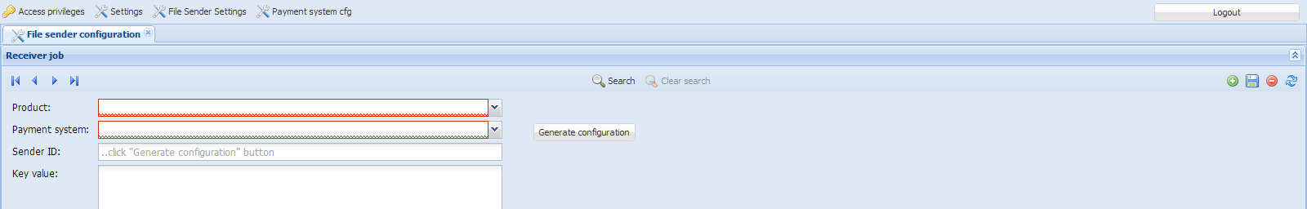
Action bar

Button | Action
First | Move to first entity
Previous | Move to previous entity
Next | Move to next entity
Last | Move to last entity
Search | Open search window
Clear search | Remove search filter
New | Create new entity
Save | Save recent data for entity
Delete | Delete recent entity
Reload | Reload entity

4. Configuration button
Auto generate 'Sender ID' and 'Key value' fields. And fill 'Sql configuration' with predefined configuration depend on chosen 'payment system'

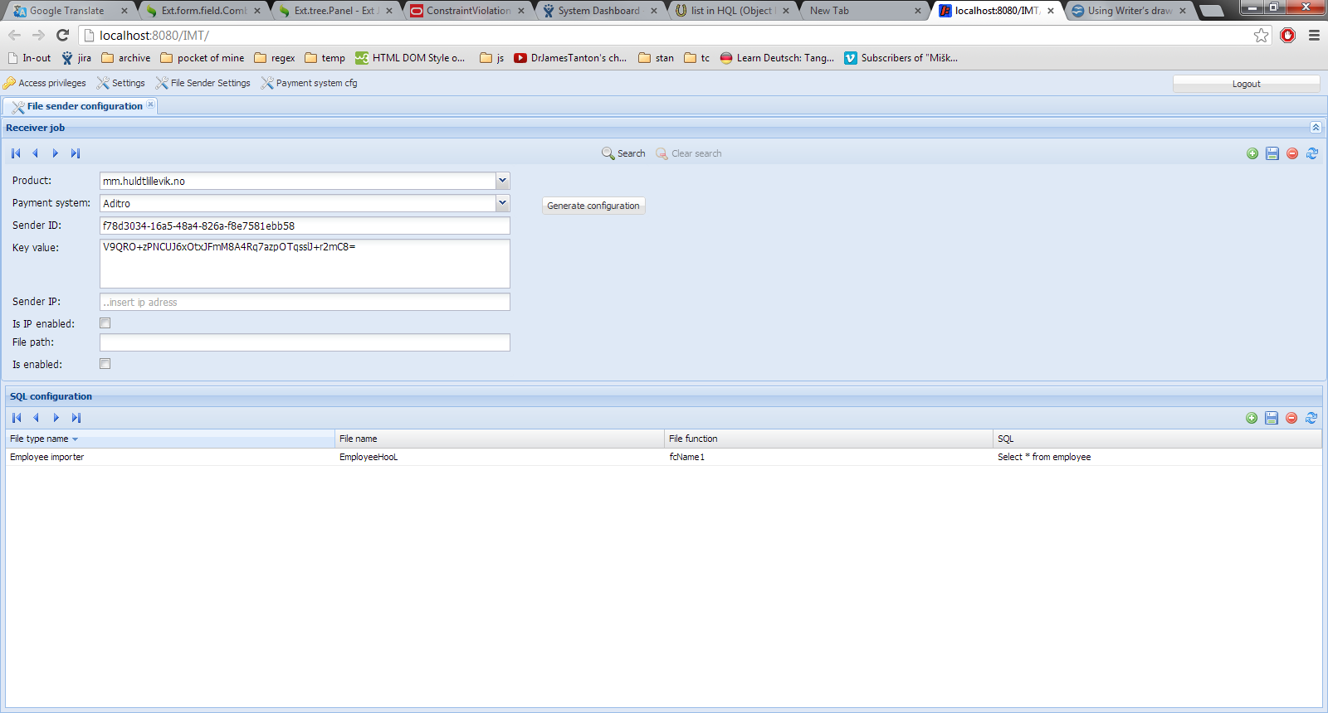
Choose 'Payment system' to generate predefine ''SQL configuration'' and 'Seder ID' and 'Key value' fields

5. Search window
1. Choose search criteria ('Product name' for ReceiverJob form)
        - Click 'Filter search' button
        - And navigate through filtered entities

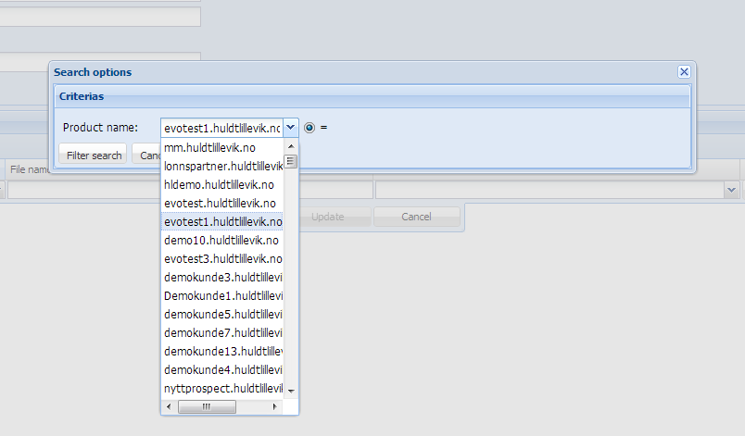

6. Clear search
'Clear search' button is active.

1. Click 'Clear search' button to remove search filter
OR
2. Start another search with different criteria

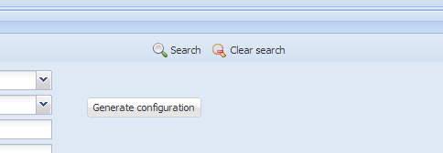

7. SQL window on 'SQL configuration' grid
To edit sql query, open 'SQL editor'. Enter query and click 'OK' button.

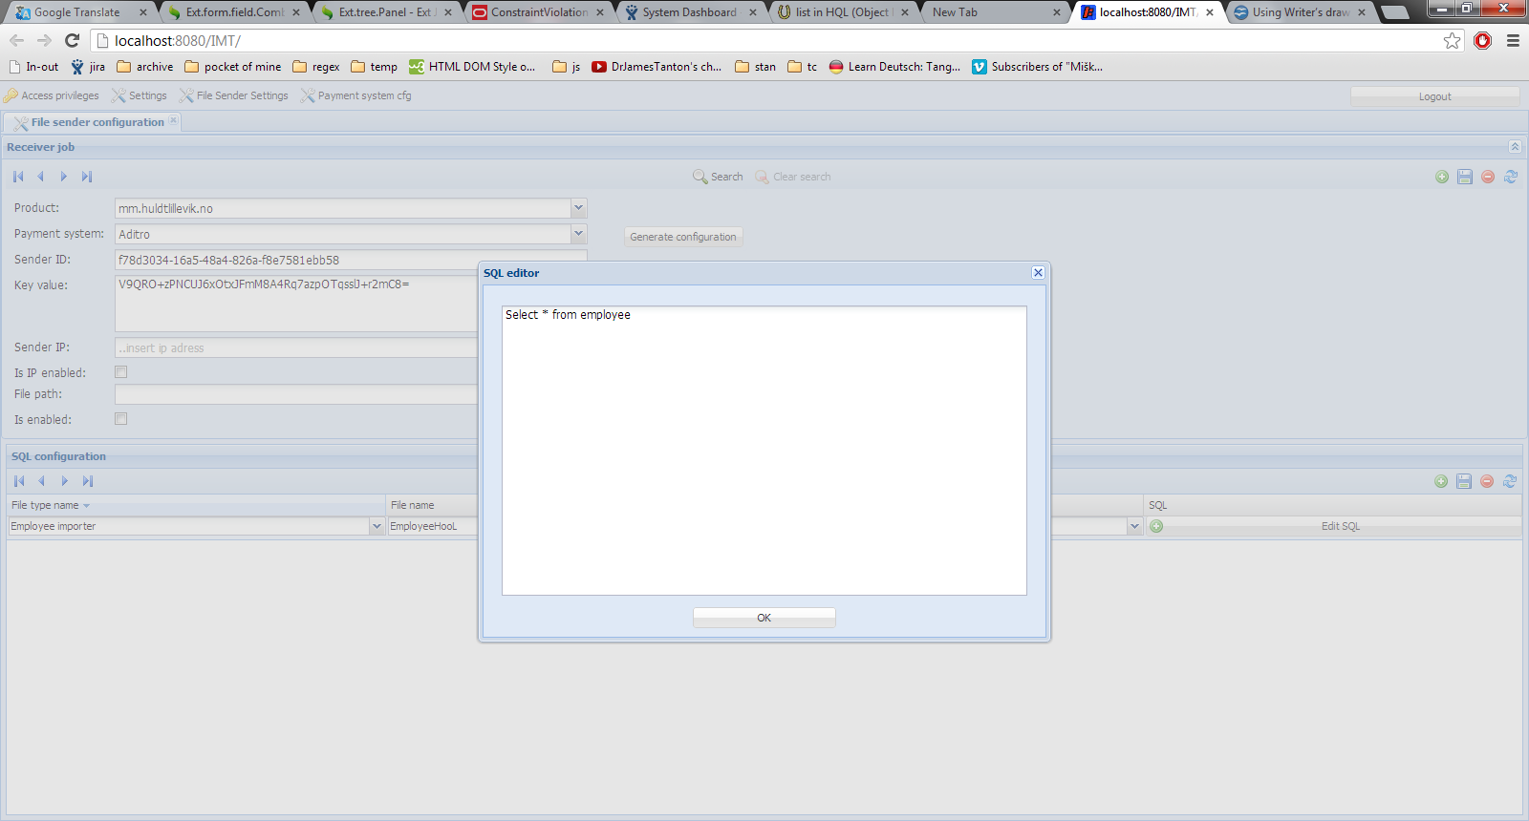
Click 'Edit SQL' to open 'Sql editor'
'SQL editor' window

Payment system configuration application

- Basic application view

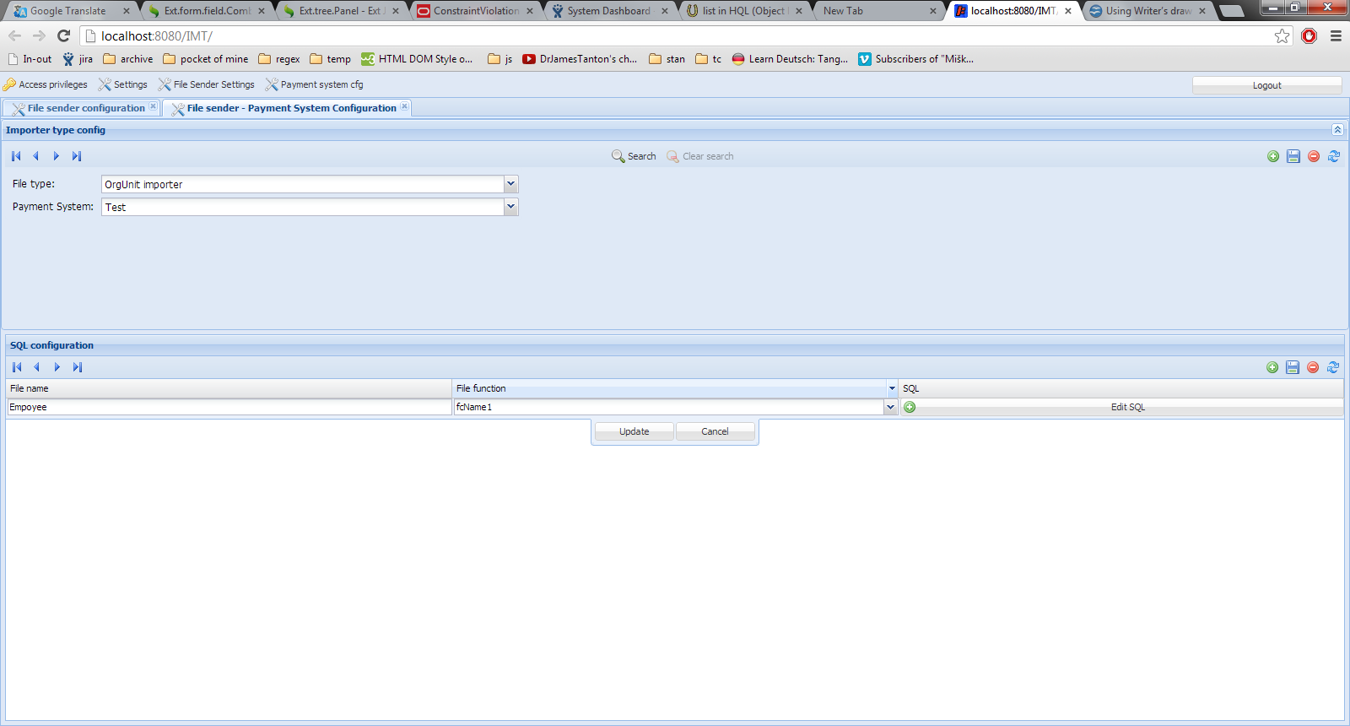

- Entities and fields

Importer type config entity

Fields | Description
File type | Choose type of file (OrgUnit, Employee, NextOfKin...)
Payment system | Choose Payment system (Aditro, ..)

Sql configuration entity

Fields | Description
File name | Name of file
File function | Forward 'file function' to receiver
Sql | Query that get executed to sender system

- Action bar
Use action bar buttons to control form and loaded entity.

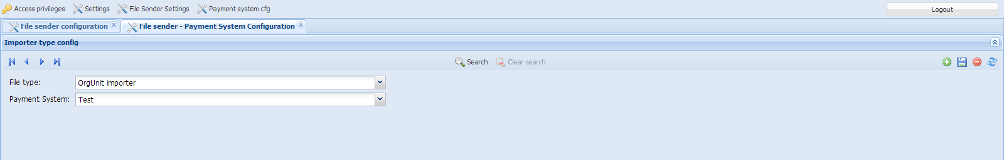
Action bar

Button | Action
First | Move to first entity
Previous | Move to previous entity
Next | Move to next entity
Last | Move to last entity
Search | Open search window
Clear search | Remove search filter
New | Create new entity
Save | Save recent data for entity
Delete | Delete recent entity
Reload | Reload entity

4. Search window
1. Choose search criteria ('File type' for 'Importer type config' form)
        - Click 'Filter search' button
        - And navigate through filtered entities

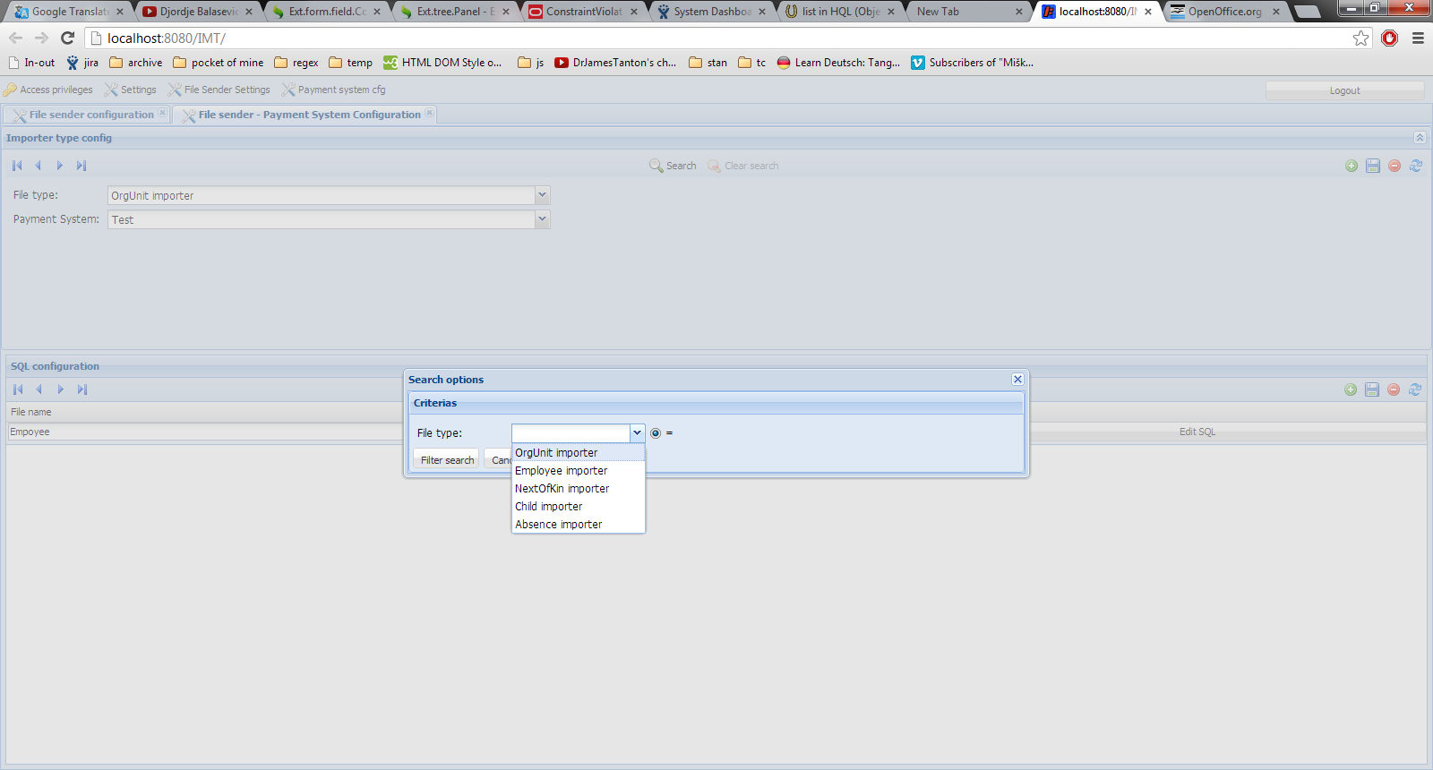

5. Clear search
'Clear search' button is active.

1. Click 'Clear search' button to remove search filter
OR
2. Start another search with different criteria

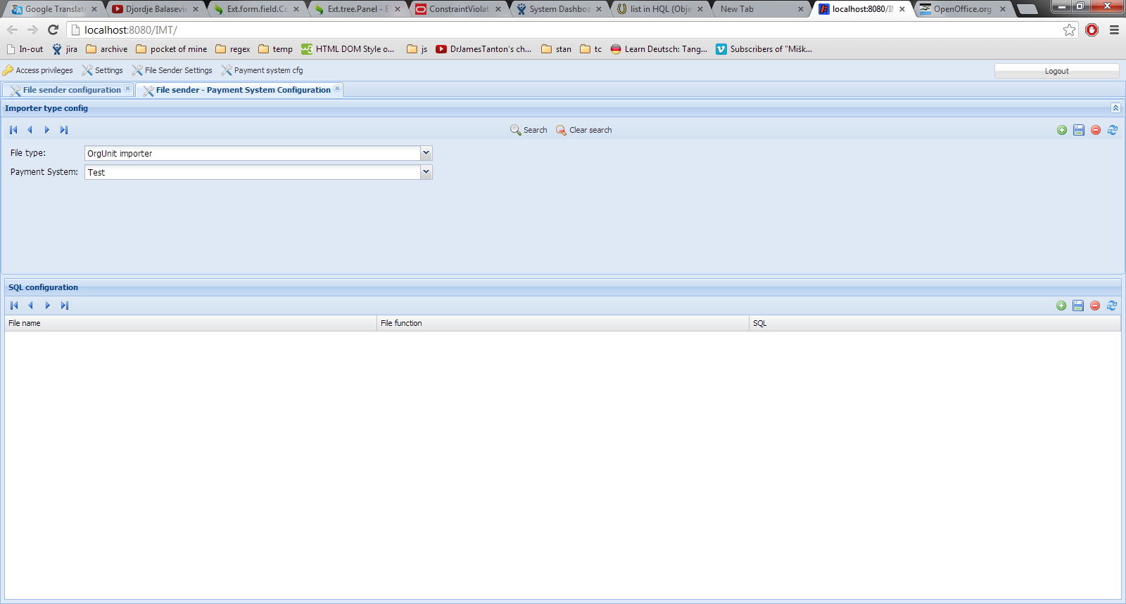
'Clear search' button

6. SQL window on 'SQL configuration' grid
To edit sql query, open 'SQL editor'. Enter query and click 'OK' button.

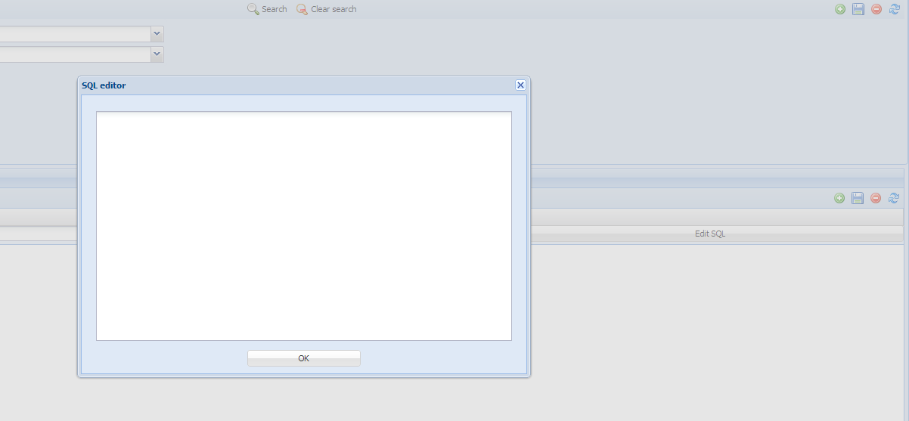
Click 'Edit SQL' to open 'Sql editor'
'SQL editor' window

